**DC Extraction**

Transfer function of filter:

Filter Response:

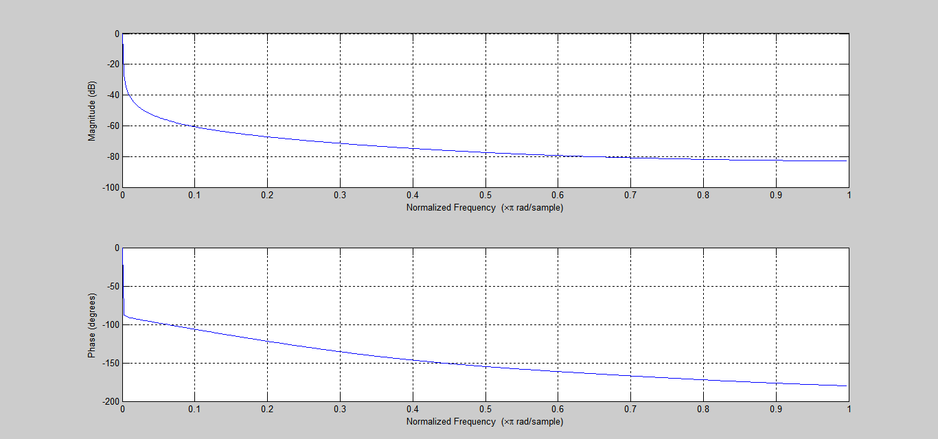

Output obtained from sample input (Python):

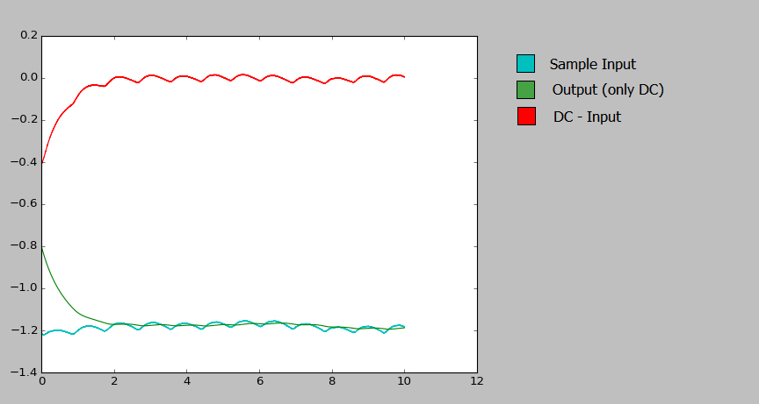

Output obtained from sample input (Python) with initial offset:

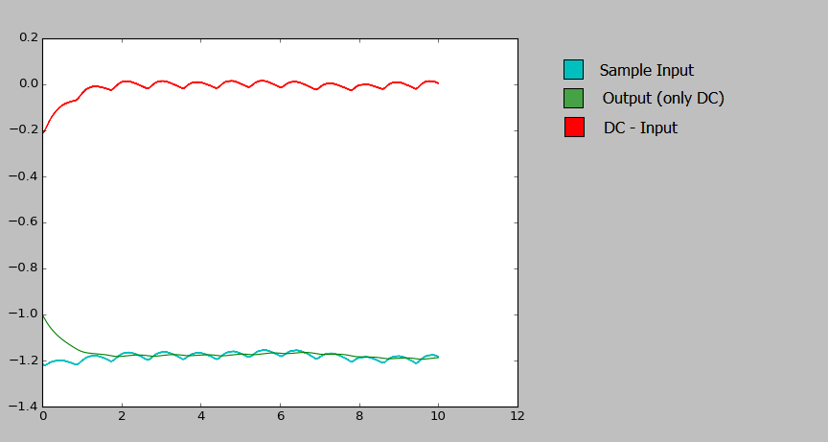

(The filtered output has an initial value of -1.1. This will change when we use actual data.)